Load Testing - JMeter

We have performed Load Testing on our website using JMeter tool.

Test – HTTP GET Request of all the pages

Web-Pages:

1. Dashboard
2. Profile
3. Stock Info
4. Login
5. Landing

# Dashboard Page

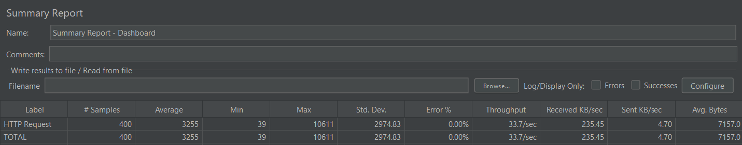

|  |  |  |  |  |  |
| --- | --- | --- | --- | --- | --- |
| Number of Users | Ramp-up Period | Loop Count | Total Samples  (Users*Loops) | Average Error(In %) | Throughput  (Response/s) |
| 200 | 2 | 2 | 400 | 0 | 33.7 |
| 400 | 2 | 2 | 800 | 7.12 | 11.1 |
| 600 | 2 | 2 | 1200 | 44.8 | 14 |

# Profile Page



|  |  |  |  |  |  |
| --- | --- | --- | --- | --- | --- |
| Number of Users | Ramp-up Period | Loop Count | Total Samples  (Users*Loops) | Average Error(In %) | Throughput  (Response/s) |
| 200 | 2 | 2 | 400 | 0 | 36.5 |
| 400 | 2 | 2 | 800 | 8.25 | 11.6 |
| 600 | 2 | 2 | 1200 | 56.08 | 14 |

# StockInfo Page



|  |  |  |  |  |  |
| --- | --- | --- | --- | --- | --- |
| Number of Users | Ramp-up Period | Loop Count | Total Samples  (Users*Loops) | Average Error(In %) | Throughput  (Response/s) |
| 200 | 2 | 2 | 400 | 0 | 80.6 |
| 400 | 2 | 2 | 800 | 13 | 9.3 |
| 600 | 2 | 2 | 1200 | 65.08 | 13.9 |

# Login Page



|  |  |  |  |  |  |
| --- | --- | --- | --- | --- | --- |
| Number of Users | Ramp-up Period | Loop Count | Total Samples  (Users*Loops) | Average Error(In %) | Throughput  (Response/s) |
| 200 | 2 | 2 | 400 | 0 | 61.3 |
| 400 | 2 | 2 | 800 | 9.62 | 11.7 |
| 600 | 2 | 2 | 1200 | 48.5 | 12.7 |

# Landing Page



|  |  |  |  |  |  |
| --- | --- | --- | --- | --- | --- |
| Number of Users | Ramp-up Period | Loop Count | Total Samples  (Users*Loops) | Average Error(In %) | Throughput  (Response/s) |
| 200 | 2 | 2 | 400 | 0 | 4.5 |
| 400 | 2 | 2 | 800 | 10.9 | 7 |
| 600 | 2 | 2 | 1200 | 48.45 | 4.6 |

# Average Analysis:

|  |  |  |  |  |  |
| --- | --- | --- | --- | --- | --- |
| Number of Users | Ramp-up Period | Loop Count | Total Samples  (Users*Loops) | Average Error(In %) | Throughput  (Response/s) |
| 200 | 2 | 2 | 400 | 0 | 43.32 |
| 400 | 2 | 2 | 800 | 9.78 | 10.14 |
| 600 | 2 | 2 | 1200 | 52.58 | 11.84 |